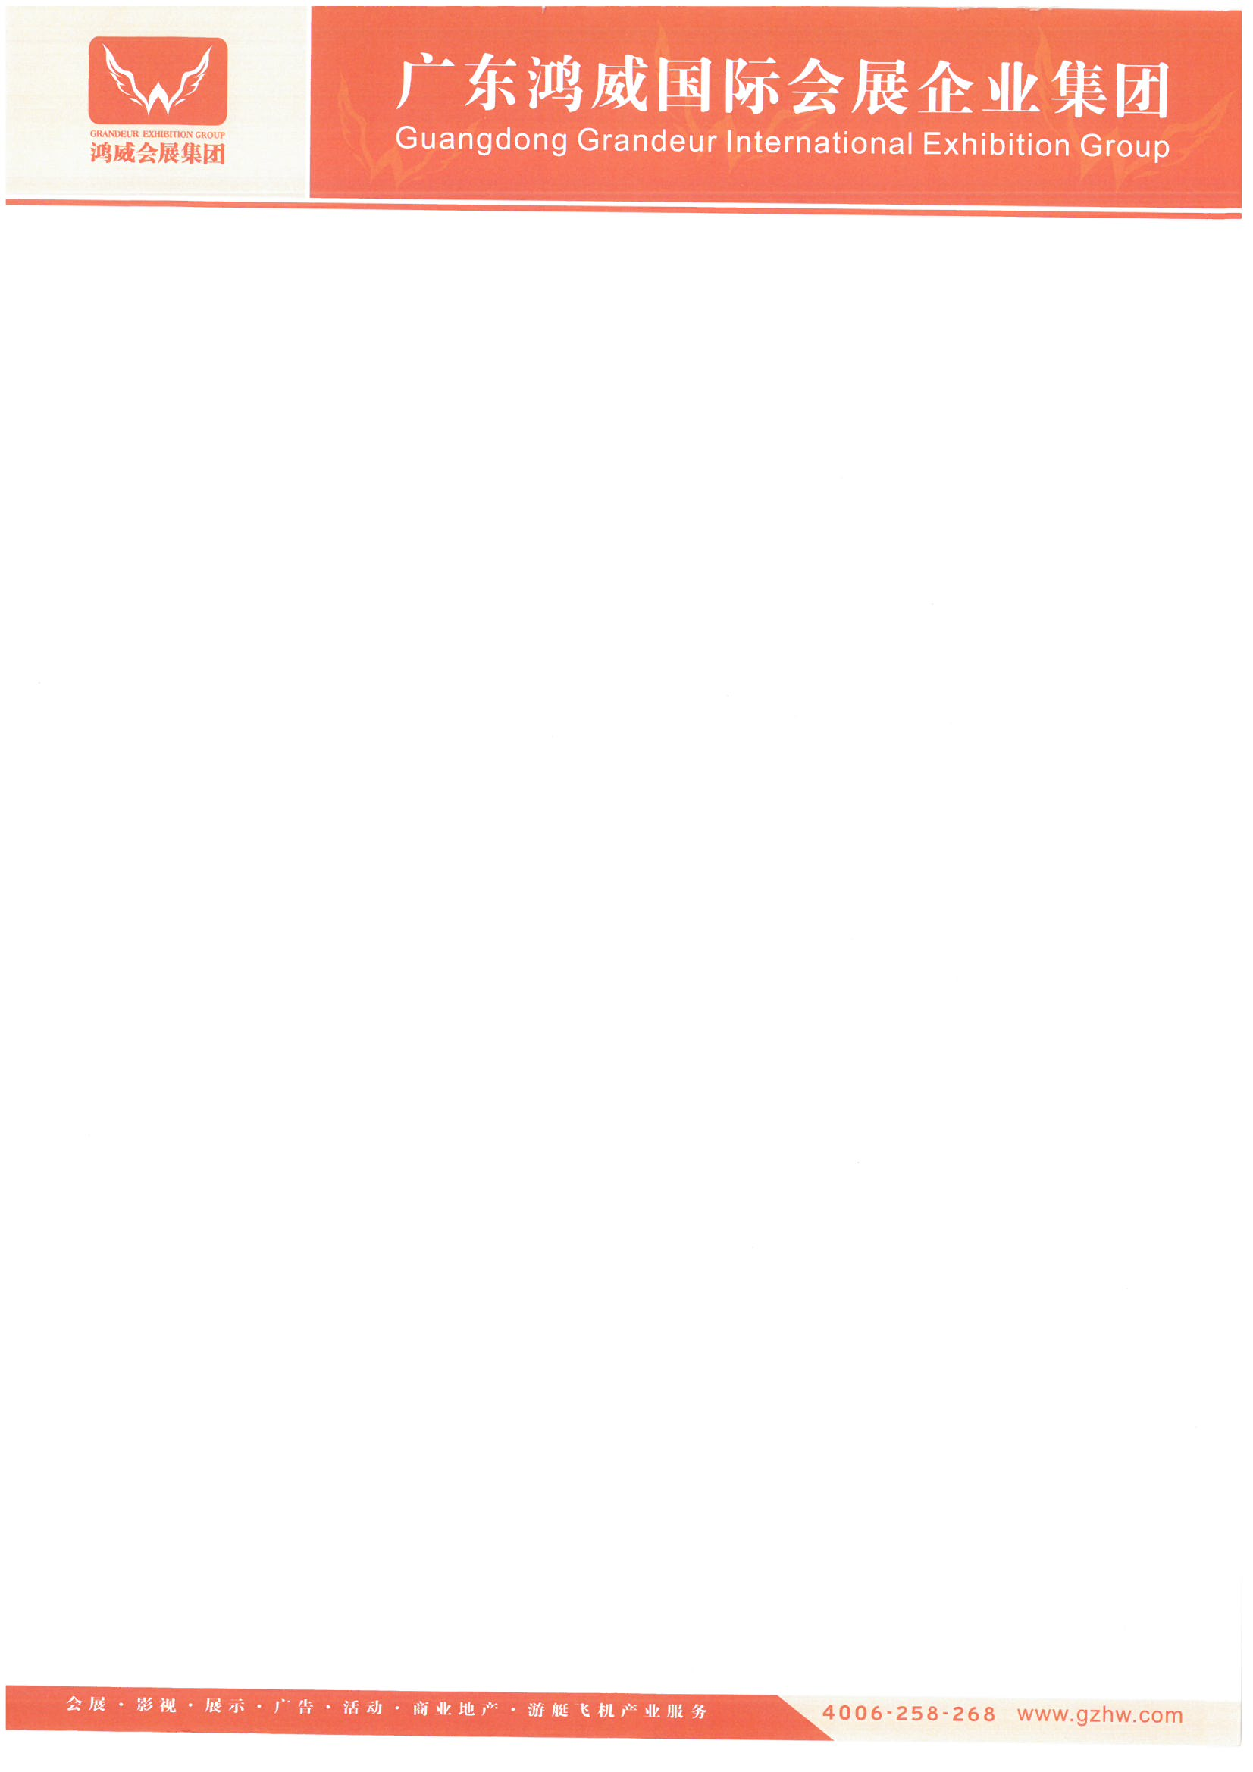

Name:

Company Name:   
Mobile:

Email:

**LETTER OF INVITATION TO ATTEND AA A2025**

Dear XXX,

On behalf of the Guangdong Grandeur International Exhibition Group, it is our pleasure to invite you to attend 2025 Asia Amusement & Attractions Expo (AAA 2025), an annual event, which will be held during **May 10 --12, 2025**, at **China Import and Export Fair Complex** (Set-up period: **May 8-9** and Dismantling period:**2:00PM-5:00PM on May 12**).

The letter of invitation is only used for the visa application purposes.Please present this letter to **Chinese Embassy** when you apply for a visa to China. All expenses incurred for the business trip will be paid by yourself. We suggest that you apply for the visa as early as possible.

Name:

Date of Birth:

Passport No:

Country:

Welcome to AAA 2025. We really hope that you would get a fruitful and rewarding experience.

Yours sincerely,   
Guangdong Grandeur International Exhibition Group